LOAN APPROVAL INTELLIGENCE & RISK ASSESSMENT SYSTEM
Exploratory Data Analysis (EDA) Report
Project Level: Level 1 — Data Understanding, Transformation and Analysis

Submitted by:
Poornima M
1WN25CS171
CSE- T
Team Members:
Poornima B -1WN25CS170
Poornima M-1WN25CS171
Poorvi Mohan Hosmani-1WN25CS172
Pradyun Kumar Rao-1WN25CS173
Submitted to:
[Faculty Name]
Institution:
BMSCE
Academic Year:
2026-27

INTRODUCTION
The Loan Approval Intelligence & Risk Assessment System project focuses on understanding the factors associated with loan approval decisions through data analysis. Financial institutions receive loan applications from customers with different income levels, educational backgrounds, employment statuses, credit histories, and property locations. Analysing these characteristics can help identify patterns in loan approval and rejection.
This report presents the data transformation, outlier analysis, and exploratory data analysis (EDA) performed on the cleaned loan dataset. The analysis includes the creation of a combined income feature, examination of numerical distributions, comparison of loan approval status across different applicant characteristics, and identification of relationships between numerical variables. The findings are used to summarise meaningful patterns in the dataset and support further statistical analysis and preprocessing.

OBJECTIVES OF ANALYSIS
1. To create useful features from the existing dataset for easier analysis.
2. To identify and examine potential outliers in numerical variables.
3. To understand the distribution of loan approval and rejection.
4. To analyse the relationship between applicant characteristics and loan approval status.
5. To examine correlations among numerical variables.
6. To document key findings that may support subsequent statistical analysis and preprocessing.

DATASET OVERVIEW
The dataset used for this project is the cleaned loan approval dataset, which contains information about applicants, their financial details, loan requirements, and loan approval status.
The dataset consists of 614 records and 13 original columns. These columns include applicant income, co-applicant income, loan amount, credit history, education, marital status, property area, and loan status.
The target column, Loan_Status, indicates whether a loan application was approved or rejected. The dataset was checked for missing values and duplicate records. The checks showed zero missing values and zero duplicate records in the cleaned dataset.
The Customer_ID column serves as an identifier and is not treated as a financial measurement during exploratory analysis.
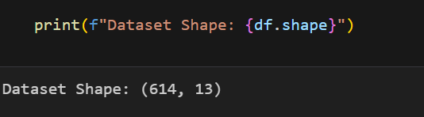
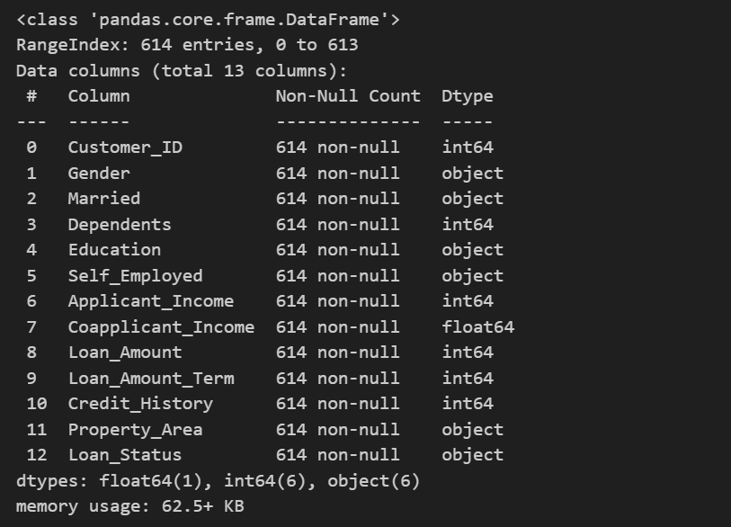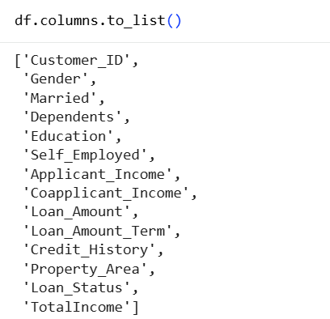

FEATURE ENGINEERING
Feature engineering was performed to create a new variable called Total Income. This variable represents the combined income of the applicant and co-applicant.
The new feature was calculated using the following formula:
TotalIncome = Applicant_Income + Coapplicant_Income
This feature provides a combined view of the financial resources available to the loan applicants. Descriptive statistics and a distribution plot were used to understand the variation in total income.
The new feature was added to the dataset for further exploratory data analysis. The original income columns were retained to allow individual and combined incomecomparisons.
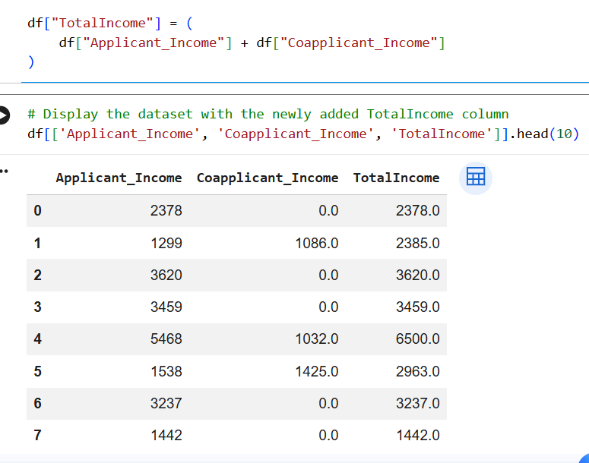
OUTLIER ANALYSIS
Outlier analysis was performed to identify unusually high or low values in the numerical columns of the loan approval dataset. The Interquartile Range (IQR) method was used for this analysis.
The IQR is calculated as the difference between the third quartile (Q3) and the first quartile (Q1).
IQR = Q3 − Q1
IQR = Q3 − Q1

The lower and upper limits were calculated using the following formulas:
Lower Limit = Q1 − 1.5 × IQR
Upper Limit = Q3 + 1.5 × IQR
Values outside these limits were identified as potential outliers. The analysis was performed on Applicant_Income, Coapplicant_Income, Loan_Amount, Loan_Amount_Term, and Total Income. Boxplots were also generated to visualize the distributions and identify extreme observations.
The analysis identified potential outliers in several numerical columns. However, an observation outside the IQR limits is not necessarily an error. Such values may represent genuine differences in applicants' financial circumstances.
Therefore, the observations were not automatically removed. They were retained for further analysis to avoid losing potentially useful information. Special care was taken when interpreting Loan_Amount_Term because repeated values can produce an IQR of zero, causing the standard IQR rule to flag many observations.

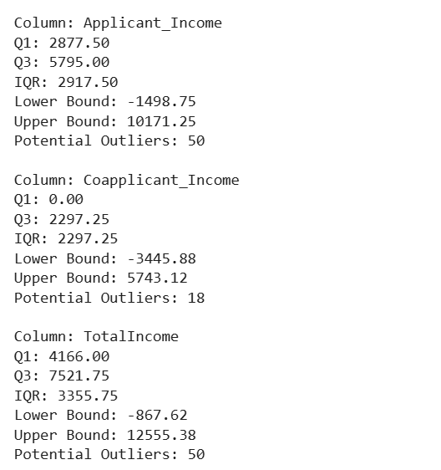
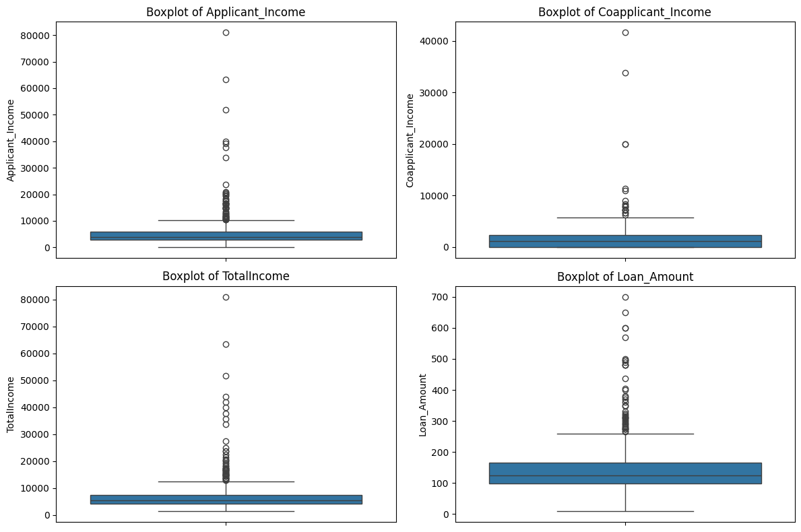

Exploratory Data Analysis (EDA)

Exploratory Data Analysis was performed to understand the characteristics of the dataset and identify patterns related to loan approval. Tables and visualizations were used to compare approved and rejected applications.
- Loan Approval Distribution
The distribution of the target variable, Loan_Status, was analyzed to determine the number and percentage of approved and rejected applications. The dataset contains 614 applications, of which 422 were approved and 192 were rejected. This corresponds to approximately 68.73% approved applications and 31.27% rejected applications.
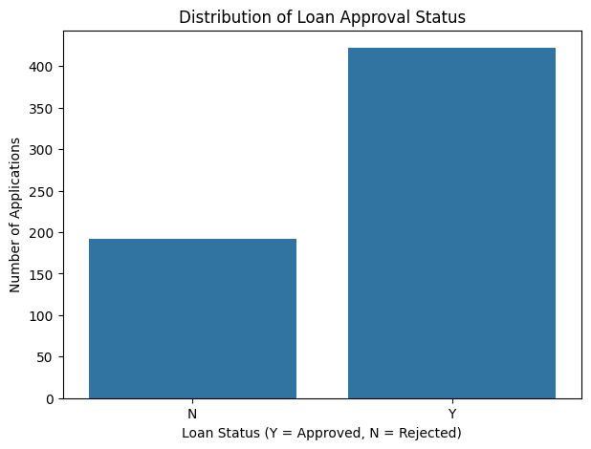

- Observation — Credit History and Loan Approval
The analysis indicates a strong association between credit history and loan approval status. Applicants with Credit_History = 1 had a substantially higher approval rate than applicants with Credit_History = 0. This suggests that credit history is an important factor associated with loan approval in this dataset. However, this analysis identifies an association and does not establish causation.
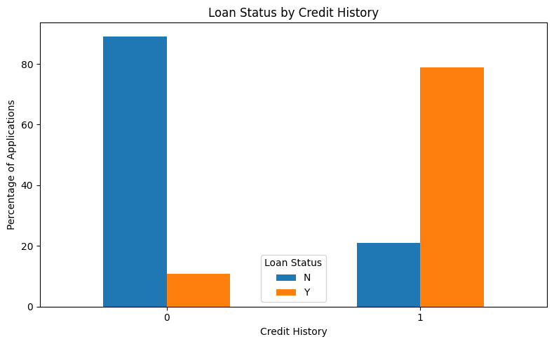

- Observation — Applicant Income and Loan Approval
Applicant income was compared across approved and rejected loan applications using descriptive statistics and a boxplot. The average and median incomes of the two groups were relatively similar in this dataset. This suggests that applicant income alone may not clearly distinguish approved applications from rejected applications. Other variables, such as credit history, may also be important when examining loan approval patterns.
This comparison is descriptive and does not establish a causal relationship between income and loan approval.
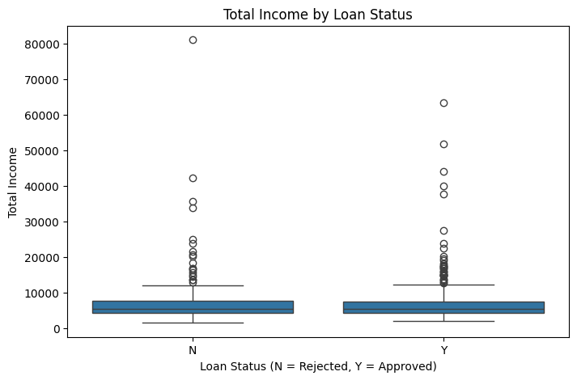

- Observation — Total Income and Loan Approval
Total income, calculated by adding applicant income and co-applicant income, was compared across approved and rejected loan applications. The group statistics and boxplot help identify differences in combined income and the spread of values between the two groups.
The results should be interpreted using the actual statistics and distributions. Higher combined income does not necessarily guarantee loan approval, as other applicant and loan characteristics may also be associated with the decision.
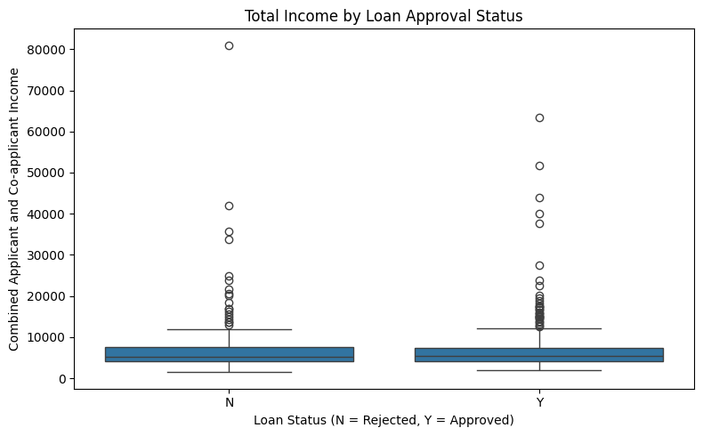

- Observation — Loan Amount and Loan Approval
Loan amounts were compared between approved and rejected applications using descriptive statistics and a boxplot. The comparison helps identify differences in the typical loan amounts and the variation within each group.
The mean and median values should be examined to determine whether the groups differ substantially. Loan amount alone may not fully explain the approval decision, as other applicant and loan characteristics may also be associated with loan approval.
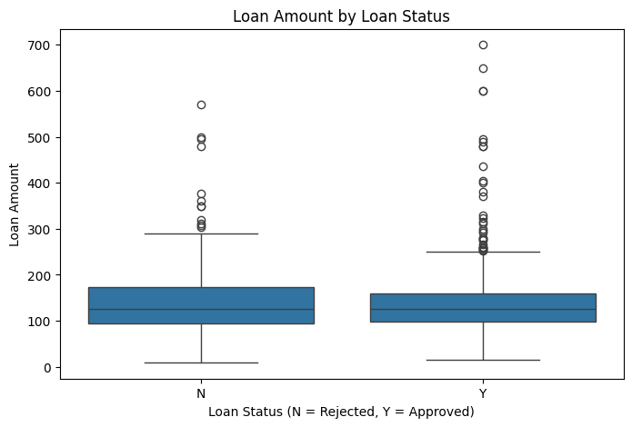

- Observation — Education and Loan Approval
Loan approval rates were compared between graduate and non-graduate applicants. In this dataset, graduates had an approval rate of approximately 70.8%, while non-graduates had an approval rate of approximately 61.2%.
This indicates that graduates had a higher observed approval rate in the dataset. However, education alone does not determine whether a loan is approved, and this comparison does not establish a causal relationship.
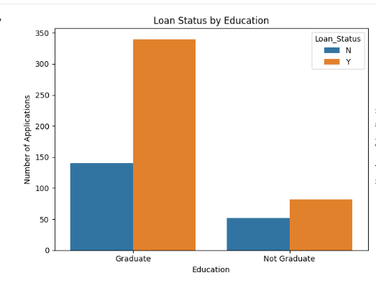

- Observation — Self-Employment and Loan Approval
Loan approval rates were compared between self-employed and non-self-employed applicants. In this dataset, the approval rates were approximately 68.1% for self-employed applicants and 68.8% for non-self-employed applicants.
The difference between these rates is small, suggesting that self-employment status alone does not clearly distinguish approved applications from rejected applications in this dataset. Other applicant and loan characteristics may also be associated with the approval decision.
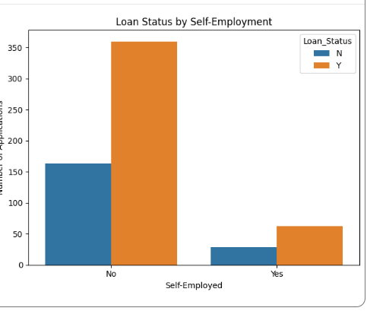

- Observation — Property Area and Loan Approval
Loan approval rates were compared across rural, semiurban, and urban property areas. In this dataset, the approval rates were approximately 61.5% for rural applicants, 76.8% for semiurban applicants, and 65.8% for urban applicants.
The semiurban category had the highest observed approval rate, while the rural category had the lowest. This indicates a difference in approval patterns across property areas in the dataset. However, these results show an association and do not establish that property area causes loan approval.
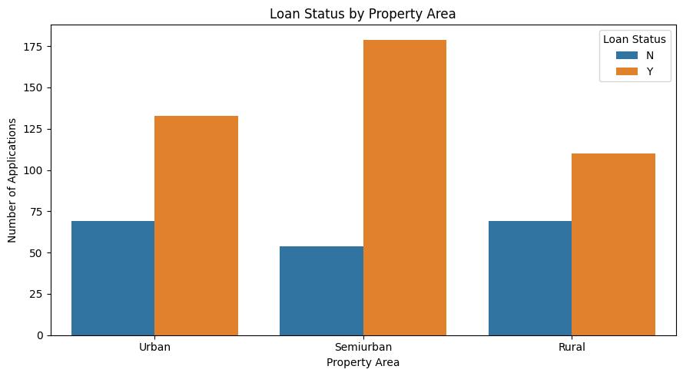

- Observation — Correlation Analysis
Correlation analysis was performed to examine the relationships between numerical variables in the loan approval dataset. The correlation matrix and heatmap help identify the direction and strength of linear relationships between these variables.
A positive correlation indicates that two variables tend to increase together, while a negative correlation indicates that one tends to decrease as the other increases. Correlations close to zero indicate a weak linear relationship.
Correlation does not imply causation. Furthermore, the correlation between numerical variables alone does not establish their importance in determining loan approval.
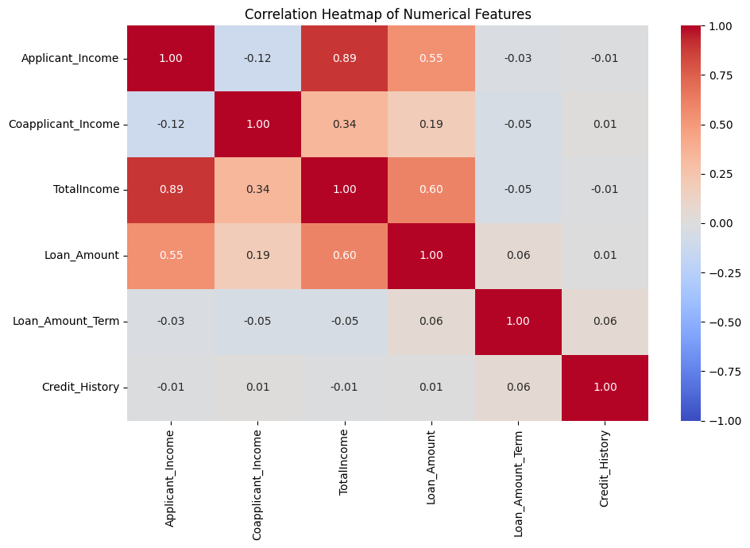

Key Findings

The exploratory data analysis produced the following important findings:
- Loan Approval Distribution: Out of 614 applications, 422 (68.73%) were approved and 192 (31.27%) were rejected.
- Credit History: Applicants with a credit history value of 1 had a substantially higher approval rate than applicants with a value of 0. This was one of the clearest differences observed in the analysis.
- Applicant Income: The average and median applicant incomes were relatively similar between approved and rejected applications. Applicant income alone did not clearly distinguish the two groups.
- Total Income: The combined income feature helped compare the financial resources of applicants. The boxplots showed variation and extreme values in both approval categories.
- Loan Amount: The distributions of loan amounts for approved and rejected applications showed considerable overlap, indicating that loan amount alone does not fully distinguish the two groups.
- Education: Graduates had a higher observed approval rate (approximately 70.8%) than non-graduates (approximately 61.2%).
- Self-Employment: The approval rates were similar for self-employed applicants (approximately 68.1%) and non-self-employed applicants (approximately 68.8%).
- Property Area: Semiurban applicants had the highest observed approval rate (approximately 76.8%), followed by urban applicants (65.8%) and rural applicants (61.5%).
- Outlier Analysis: The IQR method identified potential outliers in several numerical variables. These observations were retained rather than automatically removed because extreme values are not necessarily data errors.
- Correlation Analysis: Applicant income and total income showed a strong positive correlation of approximately 0.89. Total income and loan amount showed a positive correlation of approximately 0.60. These relationships describe numerical associations and do not establish causation.

Conclusion

The Exploratory Data Analysis performed for the Loan Approval Intelligence & Risk Assessment System provided a better understanding of the cleaned loan dataset and the patterns associated with loan approval.

The analysis included dataset inspection, creation of the TotalIncome feature, identification of potential outliers using the IQR method, examination of loan approval distribution, comparison of applicant characteristics, and correlation analysis.

The results showed a strong association between credit history and loan approval. Differences were also observed across education levels and property areas, while approval rates were relatively similar across self-employment categories. Numerical comparisons helped describe applicant income, combined income, and loan amount distributions.

Potential outliers were retained to avoid removing legitimate observations without sufficient justification. Correlation analysis provided additional information about relationships between numerical variables.

Overall, this stage established a foundation for further statistical analysis and data preprocessing. The findings describe patterns in the available dataset and should not be interpreted as proof that any individual characteristic causes loan approval or rejection.

